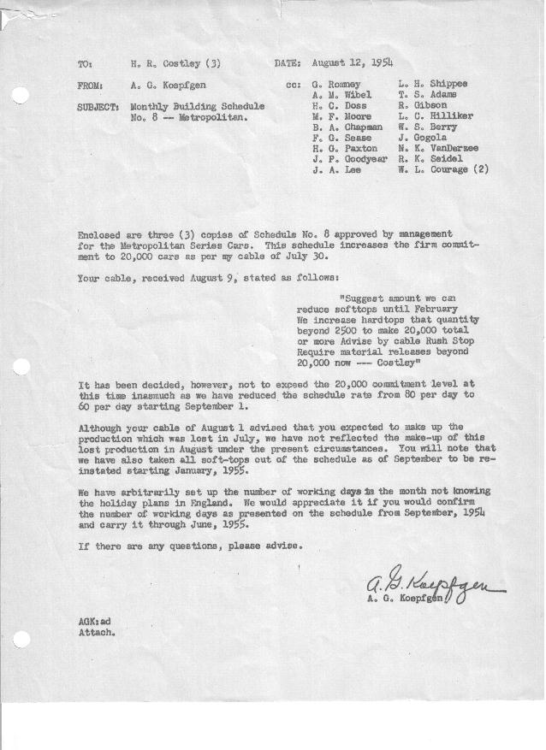

FORM PLAN 68 REV. 9-40-N.K.P PRINTED IN U.S.A

SCHEDULE NO. ______8_________ DATE August 12, 1954 MONTHLY BUILDING SCHEDULE APPROVED F. G. Sease & W.L. Courage (signed)_____DATE_ _8-12-54__ ___ REVISION NO. ________________ DATE ________________ PRODUCT APPROVED_____B. A. Chapman (signed) ___________DATE_ _8-12-54__ ___
METROPOLITAN SERIES CARS – AUSTIN MOTOR CO., LTD., ENGLAND

DESCRIPTION | BUILT  ACT◻ EST  THRU  7-31-54 | FIRM BUILDING SCHEDULE  (FABRICATED MATERIAL RELEASE) |  |  |  |  |  |  |  |  |  |  |  |  |  |  |  |  |  | GRAND  TOTAL
DESCRIPTION | BUILT  ACT◻ EST  THRU  7-31-54 | MONTH August, 1954  DAYS 12 (10 days down) |  |  | MONTH September  DAYS 22 |  |  | MONTH October  DAYS 21 |  |  | MONTH November  DAYS 22 |  |  | MONTH December  DAYS 23 |  |  | MONTH January, 1955  DAYS 21 |  |  | GRAND  TOTAL
DESCRIPTION | BUILT  ACT◻ EST  THRU  7-31-54 | DAILY | MONTH | CUM’L  TOTAL | DAILY | MONTH | CUM’L  TOTAL | DAILY | MONTH | CUM’L  TOTAL | DAILY | MONTH | CUM’L  TOTAL | DAILY | MONTH | CUM’L  TOTAL | DAILY | MONTH | TOTAL | GRAND  TOTAL
NASH
Hard-Top Conv. | 5438 |  | 530 | 5968 |  | 697 | 6665 |  | 667 | 7332 |  | 909 | 8241 |  | 946 | 9187 |  | 655 | 9840
Soft-Top Conv. | 3700 |  | 0 | 3700 |  | 0 | 3700 |  | 0 | 3700 |  | 0 | 3700 |  | 0 | 3700 |  | 212 | 3912
Total | 9138 |  | 530 | 9668 |  | 697 | 10365 |  | 667 | 11032 |  | 909 | 11941 |  | 946 | 12887 |  | 865 | 13752
HUDSON
Hard-Top Conv. | 220 |  | 322 | 542 |  | 623 | 1165 |  | 593 | 1758 |  | 411 | 2169 |  | 434 | 2603 |  | 290 | 2893
Soft-Top Conv. | 71 |  | 108 | 179 |  | 0 | 179 |  | 0 | 179 |  | 0 | 179 |  | 0 | 179 |  | 105 | 284
Total | 291 |  | 430 | 721 |  | 623 | 1344 |  | 593 | 1937 |  | 411 | 2348 |  | 434 | 2782 |  | 395 | 3177
CORPORATION - TOTAL
Hard-Top Conv. | 5658 | 71 | 852 | 6510 | 60 | 1320 | 7830 | 60 | 1260 | 9090 | 60 | 1320 | 10410 | 60 | 1380 | 11790 | 45 | 943 | 12733
Soft-Top Conv. | 3771 | 9 | 108 | 3879 | 0 | 0 | 3879 | 0 | 0 | 3879 | 0 | 0 | 3879 | 0 | 0 | 3879 | 15 | 317 | 4196
Grand Total | 9429 | 80 | 960 | 10389 | 60 | 1320 | 11709 | 60 | 1260 | 12969 | 60 | 1320 | 14289 | 60 | 1380 | 15669 | 60 | 1260 | 16929
Over/(Under) Sched. #7 | (353) |  | 0 | (353) |  | (440) | (793) |  | (420) | (1213) |  | (440) | (1653) |  | 106 | (1653)* |  | 1260 | (571)
 |  |  |  |  |  |  |  |  |  |  |  |  |  | * Includes 284 Unscheduled
 |  | MONTH February  DAYS 20 |  |  | MONTH March  DAYS 23 |  |  | MONTH April  DAYS 8 |  |  | Grand  Total
NASH
Hard-Top Conv. |  |  | 585 | 10425 |  | 694 | 11119 |  | 461 | 11580 |  | 11580
Soft-Top Conv. |  |  | 240 | 4152 |  | 284 | 4436 |  | 30 | 4466 |  | 4466
Total |  |  | 825 | 14577 |  | 978 | 15555 |  | 491 | 16046 |  | 16046
HUDSON
Hard-Top Conv. |  |  | 255 | 3148 |  | 272 | 3420 |  | 0 | 3420 |  | 3420
Soft-Top Conv. |  |  | 120 | 404 |  | 130 | 534 |  | 0 | 534 |  | 534
Total |  |  | 375 | 3552 |  | 402 | 3954 |  | 0 | 3954 |  | 3954
CORPORATION - TOTAL
Hard-Top Conv. |  | 42 | 840 | 13573 | 42 | 966 | 14539 |  | 461 | 15000 |  | 15000
Soft-Top Conv. |  | 18 | 360 | 4556 | 18 | 414 | 4970 |  | 30 | 5000 |  | 5000
Grand Total |  | 60 | 1200 | 18129 | 60 | 1380 | 19509 | 60 | 491 | 20000 |  | 20000
Over/(Under) Sched. #7 |  |  | 1200 | 629 |  | 1380 | 2009 |  | 491 | 2500 |  | 2500

